NOVAC Technology Solutions



Business Requirement Document

For

SGI Philippines – Changes in the Policy Schedule for Motor Product

Revision History

Version No. | Date | Reason For Changes | Author | Reviewer | Approver
Draft 131.1 | 18-Oct-2024 | Draft document to add the changes in the Policy schedule document | PL. Nijanthan | M. Arunkumar | Mr. Manoj Joseph
131.2 | 25-Oct-2024 | Required grey color in the Statement of Account title | PL. Nijanthan | M. Arunkumar | Mr. Manoj Joseph
131.0 | 30-Oct-2024 | Baseline document of draft version 131.2 | PL. Nijanthan | M. Arunkumar | Mr. Manoj Joseph

Table of Contents
1. Introduction 4
1.1. Purpose 4
1.2. Project Scope 4
1.2.1. Features for Future Releases 4
1.3. References 4
1.4. System Description 4
2. Functional Overview 4
2.1. Own Renewal Process 4
2.2. Assumption and Dependencies 4
3. Interface Requirements 5
3.1. Internal Interfaces 5
3.1.1. Hardware Interface 5
3.1.2. Software Interface 5
3.1.3. Communication Interface 5
3.2. External Interfaces 5
3.2.1. Hardware Interface 5
3.2.2. Software Interface 5
3.2.3. Communication Interface 5
3.3. Operating Environment Requirement 5
3.3.1. Hardware Requirements 5
3.3.2. Software Requirements 5
3.3.3. Network Requirements 5
3.3.4. Operational scenarios 5
3.4. Non Functional Requirements (NFR) 6
3.4.1. Reliability 6
3.4.2. Performance 6
3.4.3. Security 6
3.4.4. Usability 6
3.4.5. Other Requirements 6
3.5. Open Issues 6
3.6. Acceptance Criteria 6
4. Appendix A 6

Introduction

Purpose
As per the requirement, System should display the title in grey background color in the Policy schedule output pdf. This is applicable for both Individual Motor and Motor Fleet.
  - Guidelines, circulars, instructions and directions released from time to time by Philippines Insurance council .

Project Scope
To display the title in grey background color in the policy schedule output pdf. This is applicable for both Individual Motor and Motor Fleet outputs.

Features for Future Releases

References

System Description
System should display the title with grey background.

Functional Overview
System should display the title with grey background color in the Policy schedule output pdf

Policy Schedule Output Changes
System should display the title with grey background color in the Policy schedule output pdf, which is highlighted in below screen shot.
Individual Motor Output
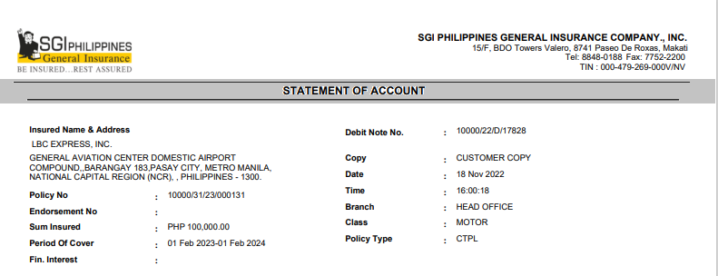
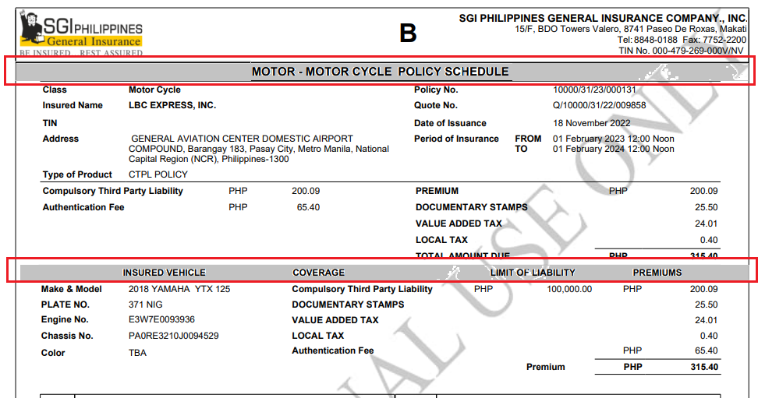
Motor Fleet Output
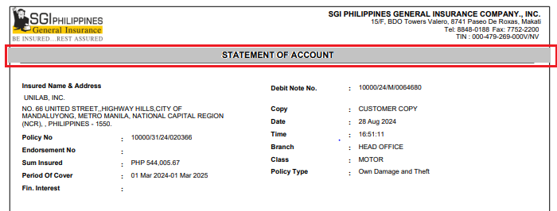
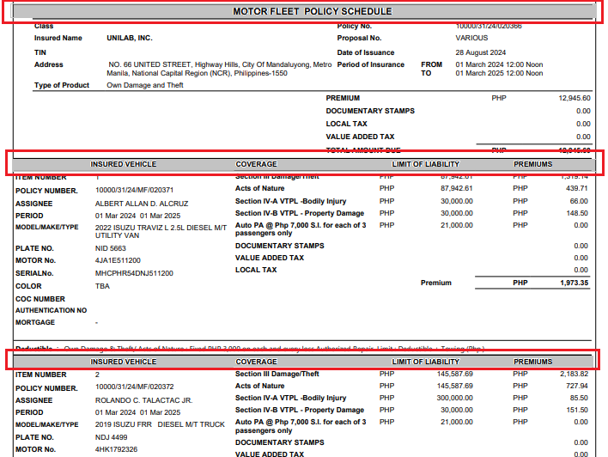

Assumption and Dependencies
<Not Applicable>

Interface Requirements

Internal Interfaces

Hardware Interface
<Not Applicable>

Software Interface
<Not Applicable>

Communication Interface
<Not Applicable>

External Interfaces

Hardware Interface
<Not Applicable>

Software Interface
<Not Applicable>

Communication Interface
<Not Applicable>

Operating Environment Requirement
<Not Applicable>

Hardware Requirements
<Not Applicable>

Software Requirements
<Not Applicable>

Network Requirements
<Not Applicable>

Operational scenarios
<Not Applicable>

Non Functional Requirements (NFR)

Reliability
<Not Applicable>

Performance
<Not Applicable>

Security
<Not Applicable>

Usability
<Not Applicable>

Other Requirements
<Not Applicable>

Open Issues
<Not Applicable>

Acceptance Criteria
- Functional testing will be executed by internal testing team, and the same will be delivered to client for UAT.

Appendix A
Not Applicable

